Name:

**Problem 1**

Source Code:

name = "Moses Bondoc"  
email = "bondocmosesfidel@gmail.com"  
university = "City College Of Angeles"  
  
print(f"Name:\t{name}\nEmail:\t{email}\nUniversity:\t{university}\n")

Sample Output: (ss)

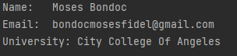

**Problem 2**

Source Code: discount = 10.5  
status = "Single"  
code = "pogiako123"  
location = "City Of Atlantis"  
age = 62  
company = "Aray Ko Company"  
website = "www.arayko.com"  
phone = "09940276364"  
job_title = "Fullstack Developer"  
department = "Developer"  
  
print("Dear %s, I hope this email finds you well." % recipient_name)  
print("I wanted to reach you out and say Hello.")  
print("I hope you're doing well and enjoying your day")  
print("It's been a while since we last spoke, and I wanted to catch up with you")  
print("Let's plan to meet up soon and have agreat time together!\n")  
  
print("Recipient: %s" %recipient_name)  
print("Sender: %s" %sender_name)  
print("Subject: %s" %subject)  
print("Version: %.1f" %version)  
print("Discount: %.2f" %discount)  
print("Status: %s" %status)  
print("Code: %s" %code)  
print("Location: %s" %location)  
print("Age: %d" %age)  
print("Company: %s" %company)  
print("website: %s" %website)  
print("Number: %s" %phone)  
print("Job Title: %s" %job_title)  
print("Department: %s" %department)

Sample Output: 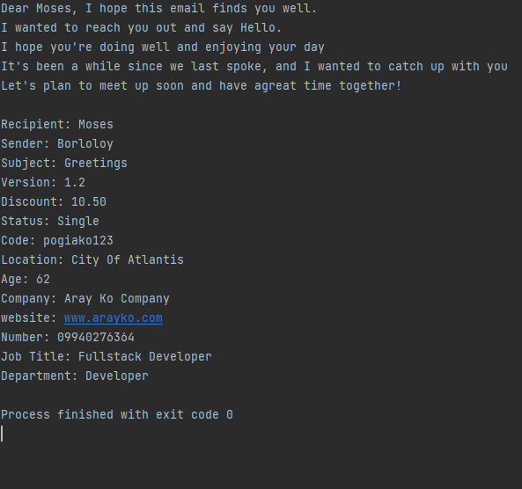

**Problem 3**

Source Code: title = input("Enter the book title: ")  
author = input("Enter the author: ")  
year = int(input("Enter the year of publication: "))  
genre = input("Enter the genre: ")  
library = input("Enter the library: ")  
member_id = input("Enter your member ID: ")  
return_date = input("Enter the return date: ")  
  
print("You have successfully reserved the book '{}' by {}.".format(title, author))  
print("Year of Publication: {}".format(year))  
print("Genre: {}".format(genre))  
print("Library: {}".format(library))  
print("Member ID: {}".format(member_id))  
print("Return Date: {}".format(return_date))

Sample Output:

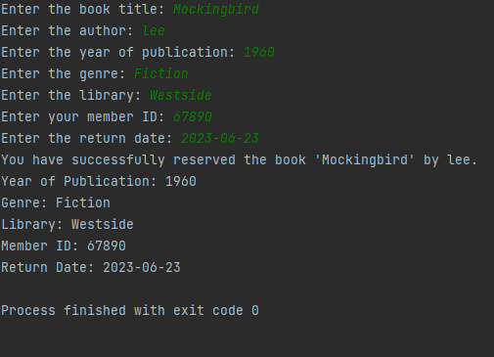

**Problem 4**

Source Code: day = int(input("Enter Day: "))  
  
if day == 1:  
 print("Monday")  
elif day == 2:  
 print("Tuesday")  
elif day == 3:  
 print("Wednesday")  
elif day == 4:  
 print("Thursday")  
elif day == 5:  
 print("Friday")  
elif day == 6:  
 print("Saturday")  
elif day == 7:  
 print("Sunday")

Sample Output:

